 

# “3D HOLOGRAPHIC PROJECTION”

Mini project report submitted to

**Dr. Babasaheb Ambedkar Technological University**

In partial fulfillment of requirement for the award of degree of

## Bachelor of Technology

Under the

## Faculty of Engineering and Technology

In the discipline

## Basic science and Humanities By

**Kunal Bharat Bagul**

First year Computer Engineering

**Guide by**

## Prof. Lalita Patil

**Department Of Basics Sciences And Humanities**

### Godavari Foundation’s Godavari College of Engineering, Jalgaon

(NAAC Accredited)

(An affiliated to Dr. Babasaheb Ambedkar Technological University) 2022-23

Godavari Foundation’s Godavari College of Engineering, Jalgaon

(An affiliated to Dr. Babasaheb Ambedkar Technological University)



## CERTIFICATE

This is to certify that the F.Y Computer Engineering Mini Project on title “3D HOLOGRAPHIC PROJECTION” submitted by Kunal bharat Bagul. In partial fulfillment of the degree of Bachelor of Technology in the Department of Basic Sciences and Humanities, Godavari College of Engineering, Jalgaon Dr. Babasaheb Ambedkar Technological University, Lonere is a bonafide record of work carried out by him/her under my guidance and supervision. In my opinion this work has attained the standard fulfilling the requirements of the regulations of the University.

Date:

Place: Jalgaon

#### Prof. Kunal Bagul Prof. Dr. Nitin Bhole

**GUIDE H.O.D**

#### Dr. Vijaykumar Patil PRINCIPAL

Godavari Foundation’s

GODAVARI COLLEGE OF ENGINEERING, JALGAON

## DERCLARATION

I hereby declare that the work presented in this mini project "3D HOLOGRAPHIC PROJECTION" was carried out by me under the supervision of guide in Semester-II

Date:

Kunal Bharat Bagul Place: Jalgaon

# ACKNOWLEDGEMEANT

I hereby, thankfully anticipate all those who have been a great support to me for accomplishing my walk and also expect to receive the same help and an extended hand from them in the future also. I gratefully thank all our teachers especially Prof. Lalita Patil. who has helped us immensely in gathering the material and efficient details of our report. Without their support it would have been difficult for me to achieve success.

Kunal Bharat bagul Dept.Of Basic Sciences and Humanities

PRN No -2151711245023

Branch –Computer ENGINEERING

Roll no –59

|  |  |  |  |
| --- | --- | --- | --- |
| **Sr. No.** | | **CONTENTS** | **Page No.** |
| **1**. |  | **INTRODUCTION** | **3** |
| **2.** |  | **3D HOLOGRAPHIC PROJECTION TECHNOLOGY** | **4** |
|  | **2.1.** | **HOLOGRAMS** | **5** |
|  | **2.2.** | **TYPES OF HOLOGRAMS** | **5** |
| **3.** |  | **ADVANTAGES OF HOLOGRAPHIC PROJECTION** | **7** |
| **4.** |  | **WORKING OF HOLOGRAMS** | **6** |
|  | **4.1.** | **RECORDING OF HOLOGRAMS** | **8** |
|  | **4.2.** | **RECONSTRUCTION OF HOLOGRAMS** | **14** |
| **5.** |  | **ADVANCES IN HOLOGRAPHIC TECHNOLOGY** | **17** |
| **6.** |  | **APPLICATIONS AND FUTURE SCOPE** | **19** |
| **7.** |  | **CONCLUSION** | **22** |
| **8.** |  | **REFERENCES** | **24** |

**List of figures**

|  |  |  |
| --- | --- | --- |
| **Sr. No.** | **Figure Name** | **Page No.** |
| **1.** | **Recording of reflex holograms** | **10** |
| **2.** | **Image recording** | **12** |
| **3.** | **Image reconstruction** | **13** |
| **4.** | **Image recording** | **14** |
| **5.** | **Image reconstruction** | **15** |
| **6.** | **Image reconstruction, primary image** | **16** |
| **7.** | **Image reconstruction, second image** | **16** |

1. **INTRODUCTION**

Holographic projection is the new wave of technology that will change how we view things in the new era. It will have tremendous effects on all fields of life including business, education, science, art and healthcare. To understand how a holographic projector works we need to know what a hologram is. Holography is the method we use to record patterns of light. These patterns are reproduced as a threedimensional image called a hologram. While Hungarian physicist Dennis Gabor invented the hologram in 1947. Today’s new technology provides some outstanding advantages to not only everyday consumers but also large business corporations and governments.

Three-dimensional holographic projection technology is loosely based on an illusionary technique called Peppers Ghost, and was first used in Victorian theatres across London in the 1860s. Pepper's Ghost was typically used to create ghostlike figures on stage. Hidden from the audience's view, an actor dressed in a ghostly costume would stand facing an angled plate of glass. The audience would be able to see the glass, but not the actor directly.

3D holographic projection is a rapidly growing technology. With every business desperately trying to get their product to stand out from the competitors, 3D hologram advertising and promotion is fast becoming an eye catching success. Thanks to the latest in HD projection and CGI technology, 3D holographic projection has transformed itself from its basic Victorian origins into a futuristic audio visual display used by the likes of Endemol (Big Brother), Coco-Cola and BMW. With almost limitless holographic possibilities, from life like humans to blockbuster style special effects, as well as the continual advances in technology, 3D holographic projection has a bright future ahead.

## 3D HOLOGRAPHIC TECHNOLOGY

Holography is a diffraction-based coherent imaging technique in which a complex three-dimensional object can be reproduced from a flat, two-dimensional screen with a complex transparency representing amplitude and phase values. It is commonly agreed that real-time holography is the ne plus ultra art and science of visualizing fast temporally changing 3-D scenes. The integration of the real-time or electro-holographic principle into display technology is one of the most promising but also challenging developments for the future consumer display and TV market. Only holography allows the reconstruction of natural-looking 3-D scenes, and therefore provides observers with a completely comfortable viewing experience.

A holoprojector will use holographic technology to project large-scale, high-resolution images onto a variety of different surfaces, at different focal distances, from a relatively small-scale projection device. To understand the technology used in holographic projection, we must understand the term ‘Hologram’, and the process of making and projecting holograms. Holography is a technique that allows the light scattered from an object to be recorded and later reconstructed. The technique to optically store, retrieve, and process information. The holograms preserve the 3-D information of a holographed subject, which helps to project 3D images.

### HOLOGRAMS

A hologram is a physical component or device that stores information about

the holographic image. For example a hologram can be a grating recorded on a piece of film. It is especially useful to be able to record a full image of an object in a short exposure if the object or space changes in time. Holos means “whole” and graphein means “writing”. Holography is a technique that is used to display objects or scenes in three dimensions. These 3D images are called holograms. A photographic record produced by illuminating the object with coherent light (as from a laser) and, without using lenses, exposing a film to light reflected from this object and to a direct beam of coherent light. When interference patterns on the film are illuminated by the coherent light a three-dimensional image is produced.

### TYPES OF HOLOGRAMS

A hologram is a recording in a two-or three-dimensional medium of the interference pattern formed when a point source of light (the reference beam) of fixed wavelength encounters light of the same fixed wavelength arriving from an object (the object beam). When the hologram is illuminated by the reference beam alone, the diffraction pattern recreates the wave fronts of light from the original object. Thus, the viewer sees an image indistinguishable from the original object.

There are many types of holograms, and there are varying ways of classifying them. For our purpose, we can divide them into three types: reflection hologram, transmission holograms and computer generated holograms.

#### The reflection hologram

The reflection hologram, in which a truly three-dimensional image is seen near its surface, is the most common type shown in galleries. The hologram is illuminated by a “spot” of white incandescent light, held at a specific angle and distance

and located on the viewer’s side of the hologram. Thus, the image consists of light reflected by the hologram. Recently, these holograms have been made and displayed in

colour—their images optically indistinguishable from the original objects. If a mirror is the object, the holographic image of the mirror reflects white light

#### Transmission holograms

The typical transmission hologram is viewed with laser light, usually of the same type used to make the recording. This light is directed from behind the hologram and the image is transmitted to the observer’s side. The virtual image can be very sharp and deep. Furthermore, if an undiverged laser beam is directed backward (relative to the direction of the reference beam) through the hologram, a real image can be projected onto a screen located at the original position of the object.

#### Computer Generated Holograms

Computer Generated Holography (CGH) is the method of digitally generating [holographic interference patterns. A h](http://en.wikipedia.org/wiki/Holography)olographic image can be generated

e.g. by digitally computing a holographic interference pattern and printing it onto a mask or film for subsequent illumination by suitable coherent light source. Alternatively, the holographic image can be brought to life by a holographic [3D display (](http://en.wikipedia.org/wiki/3D_display)a display which operates on the basis of interference of coherent light), bypassing the need of having to fabricate a "hardcopy" of the holographic interference pattern each time. Consequently, in recent times the term "computer generated holography" is increasingly being used to denote the whole process chain of synthetically preparing holographic light wavefronts suitable for observation.

Computer generated holograms have the advantage that the objects which one wants to show do not have to possess any physical reality at all (completely synthetic hologram generation). On the other hand, if holographic data of existing

Object is generated optically, but digitally recorded and processed, and brought to display subsequently, this is termed CGH as well.

## ADVANTAGES OF HOLOGRAPHIC

**PROJECTION**

The interest in 3D viewing is not new. The public has embraced this experience since at least the days of stereoscopes, at the turn of the last century. New excitement, interest, and enthusiasm then came with the 3D movie craze in the middle of the last century, followed by the fascinations of holography, and most recently the advent of virtual reality. Recent developments in computers and computer graphics have made spatial 3D images more practical and accessible. Modern three-dimensional (”3D”) display technologies are increasingly popular and practical not only in computer graphics, but in other diverse environments and technologies as well. A concurrent continuing need is for such practical autostereoscopic 3D displays that can also accommodate multiple viewers independently and simultaneously. A particular advantage would be afforded if the need could be fulfilled to provide such simultaneous viewing in which each viewer could be presented with a uniquely customized autostereoscopic 3D image that could be entirely different from that being viewed simultaneously by any of the other viewers present, all within the same viewing environment, and all with complete freedom of movement therein. A high resolution three dimensional recording of an object. Another feature is that these are glasses free 3D display. This 3D technology can accommodate multiple viewers independently and simultaneously, which is an advantage no other 3D technology can show. The 3D holographic technology does not need a projection screen. The projections are projected into midair, so the limitations of screen are not applicable for 3D holographic display.

## WORKING OF HOLOGRAMS

The time-varying light field of a scene with all its physical properties is to be recorded and then regenerated. Hence the working of holography is divided into two phases:

1. Recording
2. Reconstruction

#### Recording of hologram:

Basic tools required to make a hologram includes a red lasers, lenses, beam splitter, mirrors and holographic film. Holograms are recorded in darker environment, this is to avoid the noise interference caused by other light sources.

The recording of hologram is based on the phenomenon of interference. It requires a laser source, a plane mirror or beam splitter, an object and a photographic plate. A laser beam from the laser source is incident on a plane mirror or beam splitter. As the name suggests, the function of the beam splitter is to split the laser beam. One part of splitted beam, after reflection from the beam splitter, strikes on the photographic plate. This beam is called reference beam**.** While other part of splitted beam (transmitted from beam splitter) strikes on the photographic plate after suffering reflection from the various points of object. This beam is called object beam.

The object beam reflected from the object interferes with the reference beam when both the beams reach the photographic plate. The superposition of these two beams produces an interference pattern (in the form of dark and bright fringes) and this pattern is recorded on the photographic plate. The photographic plate with recorded

interference pattern is called hologram. Photographic plate is also known as Gabor zone plate in honour of Denis Gabor who developed the phenomenon of holography.

Each and every part of the hologram receives light from various points of the object. Thus, even if hologram is broken into parts, each part is capable of reconstructing the whole object.

There are two basic types of holograms:

* Reflection holograms
* Transmission holograms
  + 1. Reflection holograms form images by reflecting a beam of light off the surface of the hologram. This type of hologram produces very high quality images but is very expensive to create.
    2. Transmission holograms form images by transmitting a beam of light through the hologram. This type of hologram is more commonly seen since they can be inexpensively mass-produced. Embossed holograms, such as those found on credit cards, are transmission holograms with a mirrored backing.

#### Reflection Holograms

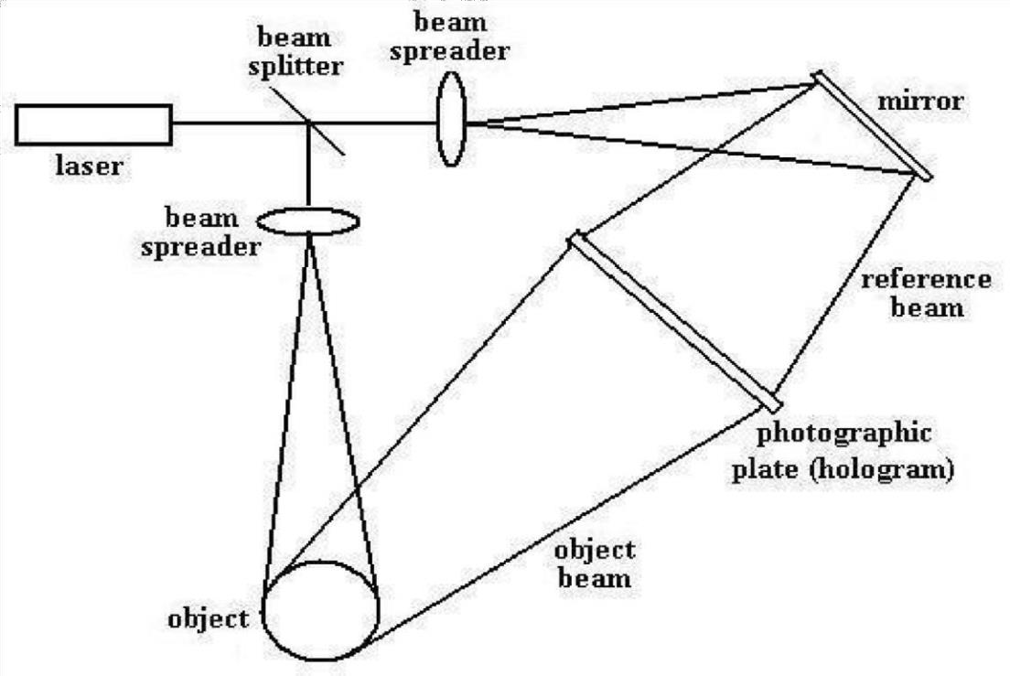

Figure 1: Recording of reflex holograms

1. Recording Reflection Holograms
2. The laser provides a highly coherent source of light. The beam of light

Hits the beam splitter, which is a semi-reflecting plate that splits the beam into two: an object beam and a reference beam.

1. The object beam is widened by a beam spreader (expanding lens ) and the light is reflected off the object and is projected onto the photographic plate.
2. The reference beam is also widened by a beam spreader and the light reflects off a mirror and shines on the photographic plate.
3. The reference and object beams meet at the photographic plate and create interference pattern that records the amplitude and phase of the resultant wave.
4. Reconstructing Reflection Holograms

1) A reconstruction beam of light is used to reconstruct the object wave front. The reconstruction beam is positioned at the same angle as the illuminating beam that was used during the recording phase.

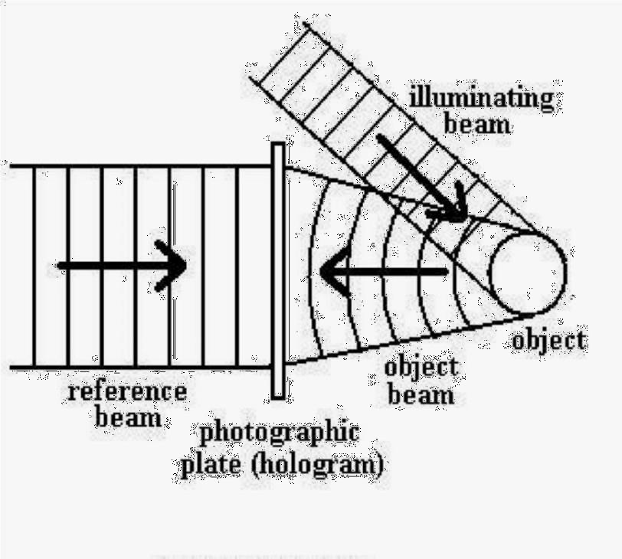

Figure 2: Image recording

The virtual image appears at behind the hologram at the same position as the object.

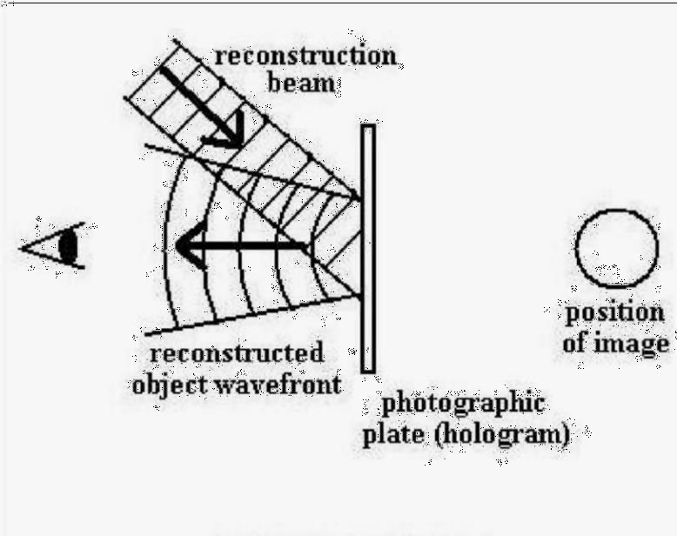

Figure 3: Image reconstruction

#### Transmission Holograms

(a) Recording Transmission Holograms

1. As with reflection holograms, a laser is used to provide a highly coherent source of light. A beam splitter and beam spreaders are also used in the recording of transmission holograms.
2. After the object beam passes through the beam spreader, the light is

reflected off a mirror and onto the object. The object beam is then reflected onto the photographic plate.

1. The reference beam is also reflected off a mirror and shines on the photographic plate.
2. The incoming object and reference beams create a resultant wave. The Amplitude and phase of the resultant wave is recorded onto the photographic plate as interference.

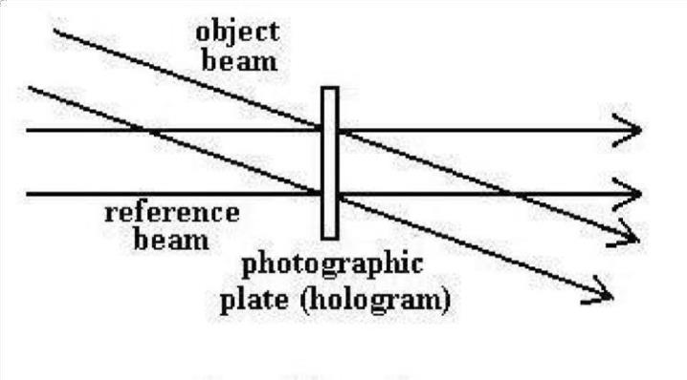

.

Figure 4: Image recording

#### Reconstructing Transmission Holograms

1. A reconstruction beam is used to illuminate the hologram and is positioned at the same angle as the reference beam that was used during the recording phase.
2. When the reconstruction beam is placed at the right angle, three beams of light will pass through the hologram.
3. An undiffracted beam (zeroth order) will pass directly through the hologram but will not produce an image.
4. A second beam forms the primary (virtual) image (first order) that is diffracted at the same angle as the incoming object beam that was used during recording.
5. A third beam forms the secondary (real) image (first order).

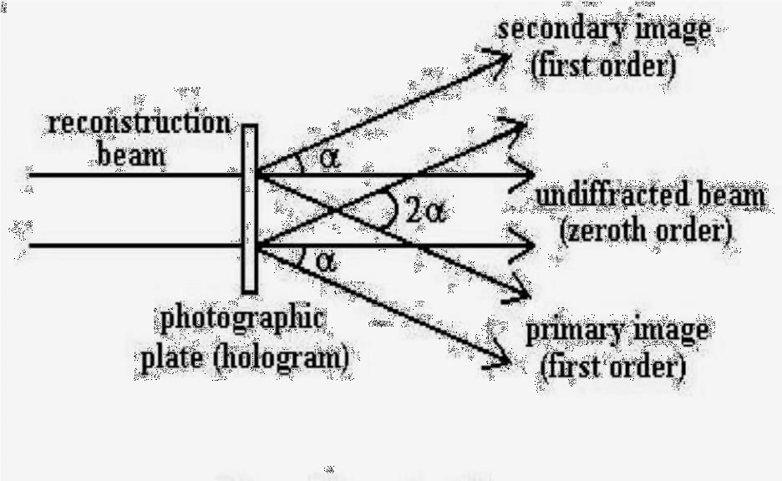

Figure 5: Image reconstruction

As we can see in the diagram, the beams that form the images are diffracted at the same angle, from the undiffracted beam. Between the image beams, the angle is twice as large, or 2 .

* 1. If we look at the hologram at the same angle as the primary image beam (also same angle as recording object beam), we will see a virtual image of the object located behind the hologram.

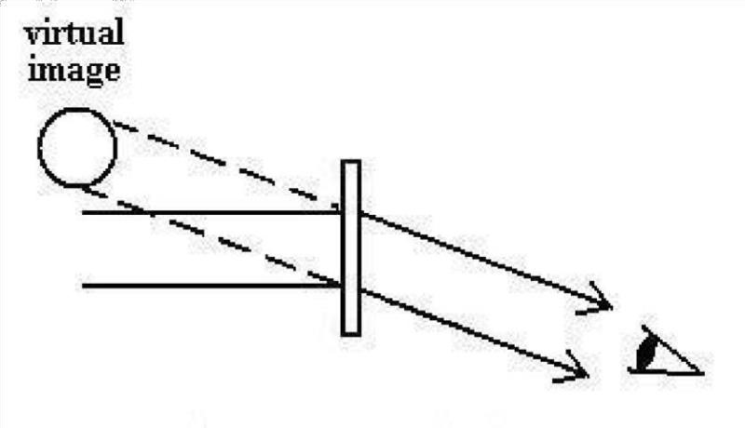

Figure 6: Image reconstruction, primary image

1) If we look at the hologram at the same angle as the secondary image beam,

we will see a real image of the object located in front of the hologram.

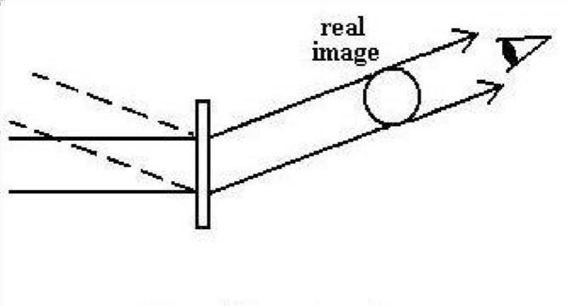

Figure 7: Image reconstruction, secondary image

## ADVANCES IN HOLOGRAPHIC TECHNOLOGY

#### Touchable holograms

The importance of haptic interaction techniques gathers much more attention with the progress of the computer graphics, the physical simulation and the visual display technologies. There have been a lot of interactive systems which aim to enable the users to handle 3D graphic objects with their hands. If tactile feedback is provided to the user’s hands in 3D free space, the usability of those systems will be considerably improved. One strategy to provide tactile feedback in 3D free space is to attach tactile displays on the user’s hands.

The method is based on a nonlinear phenomenon of ultrasound; acoustic radiation pressure. When an object interrupts the propagation of ultrasound, a pressure field is exerted on the surface of the object. This pressure is called acoustic radiation pressure.

#### Tactile display with haptic feedback

“Airborne Ultrasound Tactile Display [Iwamoto et al. 2008]” is a tactile display which provides tactile sensation onto the user’s hand. It utilizes the nonlinear phenomenon of ultrasound; acoustic radiation pressure. When an object interrupts the propagation of ultra-sound, a pressure field is exerted on the surface of the object.

#### User interfacing integrated displays

While camera-based and marker-less hand tracking systems are

Demonstrated these days, we use Wilmot (Nintendo) which has an infrared (IR) camera for simplicity. A retro reflective marker is attached on the tip of user’s middle finger.

IR LEDs illuminate the marker and two Wiimotes sense the 3D position of the finger. Owing to this hand-tracking system, the users can handle the floating virtual image with their hands.

#### 360-degree 3D system

The system was made possible by projecting high-speed video on a

spinning mirror. As the spinning mirror changes direction, different perspectives of the projected image is shown. The University of Southern California project is more realistic compared to other holographic attempt because, nearly 5, 000 individual images are reflected every second.

## APPLICATIONS AND FUTURE SCOPE

#### Marketing with 3D holographic display

This world’s innovative technology can enable observers to see lifelike images that float deep inside and project several feet in front of a display screen. Dimensional Studios, a leader in 3D visual display solutions has recently introduced its unparalleled digital signage in the UK. This world’s innovative technology can enable observers to see 3D holographic-like images that float deep inside and project several feet in front of an LCD or plasma display screen. Its aim is for advertising agencies and consumer products who wish to catch a huge impact from this new break through media.

#### Holography in education

Holography being in its infant stage has not being widely used in education. However, application of holography in education is not new. Although, the distance of transition was minimal, long distance projection is possible since the images are transmitted over the internet. Holography differs from video conferencing because the teacher appears to be in the classroom. While in video conferencing users can easily notice a screen and a camera.

#### Holography in Entertainment Industry

When one thinks about holography in the entertainment industry, the

movies Star Trek and Star Wars come into mind. In these movies, people relate with holograms as they would relate with real human. Although, what people see in these movies are not real holograms, they depict what a real hologram looks like and future capabilities of holography. In the musical industry, holography is being used for concerts. In this case, the musicians can be far away in New York while performing in

several cities around the world. Today, three dimensional television and cinemas are becoming common, and there is more to come.

3D movies in home theatres require chunky glasses which may be

uncomfortable for some people to wear. Also experts found that viewing 3D television over a long period can cause headache and eye strain due to new sensory experience. Since holography makes beamed image look like real, it should not have any future strain on the eyes nor generate headache.

#### Virtual Reality, Augmented reality and Telepresence

With the aid of a light pen, the Sketchpad draws vector lines on a computer screen. The Sketchpad contributed to the field of Human Computer Interaction, and also introduced the concept of Graphical User Interface. Virtual reality employs computer modelling and simulation, which produces images to look similar to the real world.

Telepresence differs from virtual reality, because telepresence makes it possible for a person to be virtually present in another physical location. Telepresence is applicable especially in circumstances where the person involved cannot be physically present. The absence of a real person makes telepresence an option in case of foreseen danger to the person’s life in the new environment. Telepresence is similar to holography, because they both allow objects to be transported to a new destination in 3D.

Augmented reality gives an adjusted real world, where images or text are displayed upon real objects. Museums, artists and industries are popular users of augmented reality and the usage is on the rise. Augmented reality is also becoming part of our everyday life which includes mobile appliances, shopping malls, training, and education.

#### Projection displays

Future colour liquid crystal displays (LCD’s) will be brighter and whiter as a result of holographic technology. Scientists at Polaroid Corp. have developed a holographic reflector that will reflect ambient light to produce a whiter background.

Holographic televisions may be possible within a decade but at a high price. [MIT](http://economictimes.indiatimes.com/topic/MIT) researchers recently made a prototype that does not need glasses, but true holographic commercial TV will take a year to appear. One day all TVs could be holographic, but will take 8-10 years. In future, holographic displays will be replacing all present displays in all sizes, from small phone screen to large projectors

## CONCLUSION

Holography may still be in its infant stage, but its potentials applications are aspiring. Holographic Technology and Spectral Imagining has endless applications, as far as the human mind can imagine. Holography being the closest display technology to our real environment may just be the right substitute when reality fails.With holography, educational institutions may become a global village sooner that people thought, where information and expertise are within reach. Knowledge sharing and mobility will only cost a second and learning will become more captivating and interactive. First, there is an urgent need to address the infrastructural deficiencies limiting the application of holygraphy in education.

More interestingly, the display medium of holography is very important. A 360 viewing angle is especially what is needed to maximize the use of holography in education. Being able to display a 3D hologram in free air is also vital, because interacting with holograms in a covered display may be cumbersome. In order not to limit the use of holography to a non-interactive display medium, incorporation with feedback technologies is mandatory. The haptic technology which makes it possible to touch and manipulate virtual object is especially important. As the field of haptics continues to grow and integrates with holography, interaction with holograms becomes limitless. In future, holographic displays will be replacing all present displays in all sizes, from small phone screen to large projectors

## REFERENCES

1. Ahmed Elmorshidy, Ph.D ; “*Holographic Projection Technology: The World is Changing.”;* JOURNAL OF TELECOMMUNICATIONS, VOLUME 2, ISSUE 2,

MAY 2010

1. Thomas J. Naughton; “*Capture, processing, and display of real-world 3D objects using digital holography*”; 2010 IEEE Invited Paper
2. Takayuki Hoshi, Masafumi Takahashi, Kei Nakatsuma; “*Touchable Holography*”; The University of Tokyo; 2009
3. Stephan Reichelt, Ralf Haussler, Norbert Leister, Gerald Futterer, Hagen Stolle and Armin Schwerdtner; “*Holographic 3-D Displays - Electro-holography within the*

*Grasp of Commercialization*”; Advances in Lasers and Electro Optics (April 2010)